**ASSISI CONVENT**

**SCHOOL**

SESSION-2023-2024



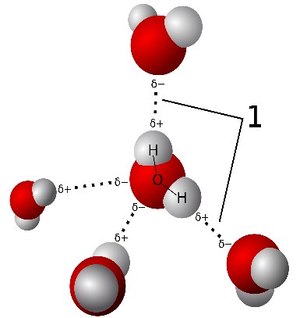

CHEMISTRY

PROJECT FILE

TOPIC-COMPARATIVE STUDY OF FERMENTATION IN VARIOUS FOOD PRODUCT

SUBMITTED TO: SUBMITTED BY:

Mrs. SARITA SENGAR ANISH JOHARI

H.O.D.(CHEMISTRY) XII A